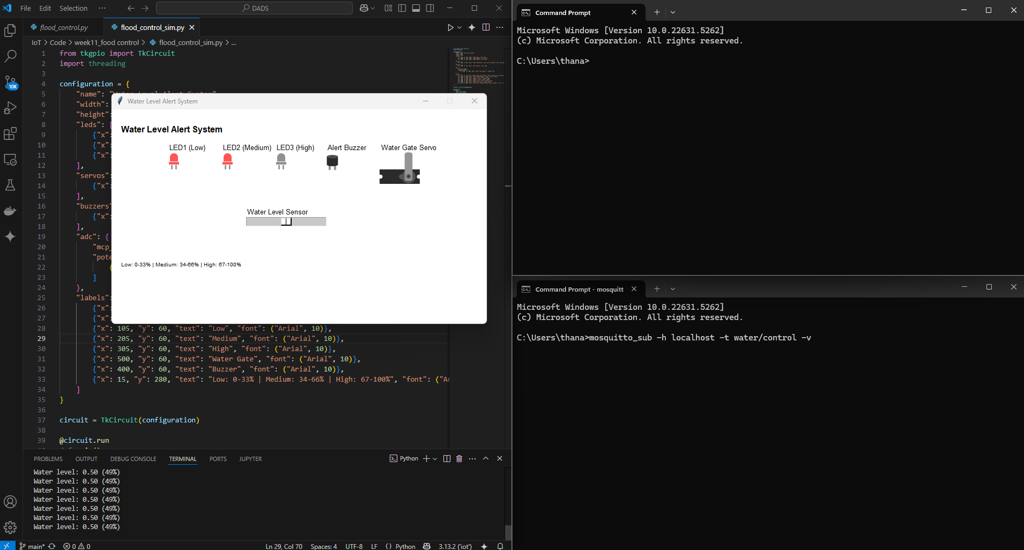

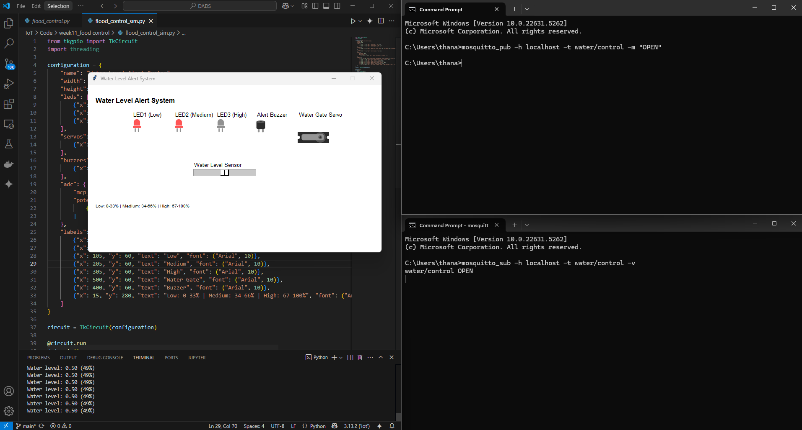

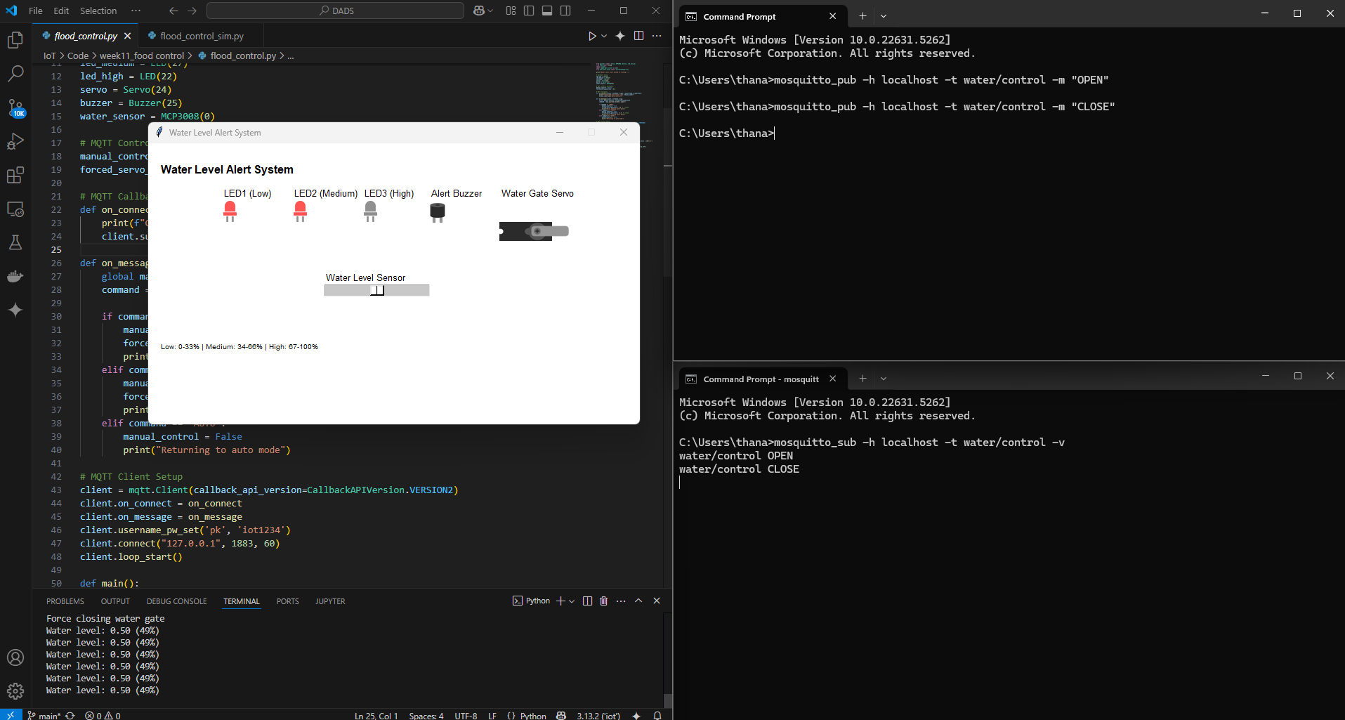

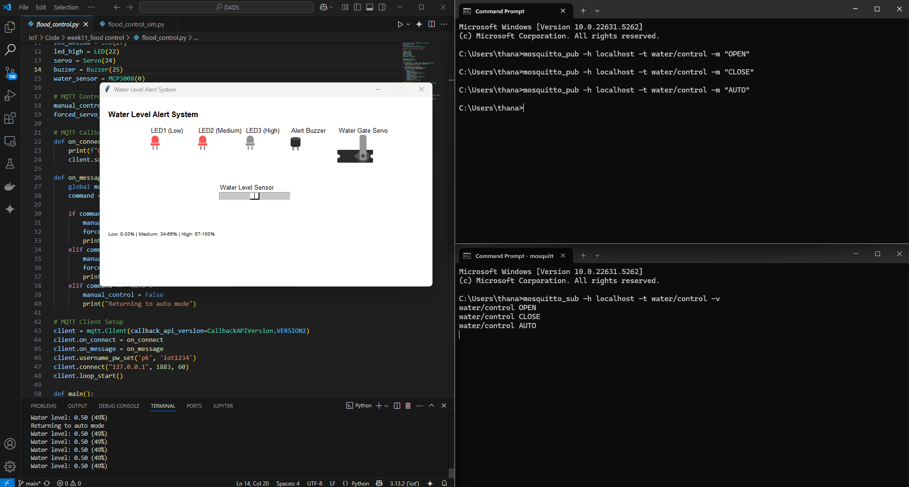
flood_control.py
from gpiozero import Servo, MCP3008, Button, LED, Buzzer
from time import sleep
import signal
import paho.mqtt.client as mqtt
from paho.mqtt.enums import CallbackAPIVersion

print("Water Level Alert System is running...")

# Hardware Setup
led_low = LED(17)
led_medium = LED(27)
led_high = LED(22)
servo = Servo(24)
buzzer = Buzzer(25)
water_sensor = MCP3008(0)

# MQTT Control Variables
manual_control = False
forced_servo_position = 0.0

# MQTT Callbacks
def on_connect(client, userdata, flags, reason_code, properties):
print(f"Connected with result code {reason_code}")
client.subscribe("water/control")

def on_message(client, userdata, msg):
global manual_control, forced_servo_position
command = msg.payload.decode().upper()

if command == "OPEN":
manual_control = True
forced_servo_position = 1.0 # เปิดสุด
print("Force opening water gate")
elif command == "CLOSE":
manual_control = True
forced_servo_position = -1.0 # ปิดสุด
print("Force closing water gate")
elif command == "AUTO":
manual_control = False
print("Returning to auto mode")

# MQTT Client Setup
client = mqtt.Client(callback_api_version=CallbackAPIVersion.VERSION2)
client.on_connect = on_connect
client.on_message = on_message
client.username_pw_set('pk', 'iot1234')
client.connect("127.0.0.1", 1883, 60)
client.loop_start()

def main():
print("System active. Press Ctrl+C to exit.")
try:
while True:
water_level = water_sensor.value

print(f"Water level: {water_level:.2f} ({int(water_level * 100)}%)")

# คุมไฟ
led_low.on() if water_level >= 0 else led_low.off()
led_medium.on() if water_level > 0.33 else led_medium.off()

if water_level > 0.66:
led_high.on()
buzzer.on()
else:
led_high.off()
buzzer.off()

# คุม Servo
if manual_control:
servo.value = forced_servo_position
else:
servo_position = (2 * water_level) - 1
servo.value = servo_position

sleep(0.5)

except KeyboardInterrupt:
client.loop_stop()
print("\nSystem stopped")

if __name__ == "__main__":
main()

flood_control_sim.py
from tkgpio import TkCircuit
import threading

configuration = {
"name": "Water Level Alert System",
"width": 700,
"height": 400,
"leds": [
{"x": 105, "y": 80, "name": "LED1 (Low)", "pin": 17},
{"x": 205, "y": 80, "name": "LED2 (Medium)", "pin": 27},
{"x": 305, "y": 80, "name": "LED3 (High)", "pin": 22}
],
"servos": [
{"x": 500, "y": 80, "name": "Water Gate Servo", "pin": 24, "min_angle": -90, "max_angle": 90, "initial_angle": 0}
],
"buzzers": [
{"x": 400, "y": 80, "name": "Alert Buzzer", "pin": 25}
],
"adc": {
"mcp_chip": 3008,
"potentiometers": [
{"x": 250, "y": 200, "name": "Water Level Sensor", "channel": 0}
]
},
"labels": [
{"x": 15, "y": 25, "text": "Water Level Alert System", "font": ("Arial", 16, "bold")},
{"x": 250, "y": 180, "text": "Water Level Sensor", "font": ("Arial", 10)},
{"x": 105, "y": 60, "text": "Low", "font": ("Arial", 10)},
{"x": 205, "y": 60, "text": "Medium", "font": ("Arial", 10)},
{"x": 305, "y": 60, "text": "High", "font": ("Arial", 10)},
{"x": 500, "y": 60, "text": "Water Gate", "font": ("Arial", 10)},
{"x": 400, "y": 60, "text": "Buzzer", "font": ("Arial", 10)},
{"x": 15, "y": 280, "text": "Low: 0-33% | Medium: 34-66% | High: 67-100%", "font": ("Arial", 10)}
]
}

circuit = TkCircuit(configuration)

@circuit.run
def main():
import flood_control
flood_control.main()

